**Functional Requirements**

* 1. ***Use Cases***
     1. **Use Case 1**

|  |  |
| --- | --- |
| Goals of actor | Create player or guest for Tic Tac Toe game. |
| Tasks | Player needs to open the program and needs to create a player or play as a guest |
| Preconditions | Needs to start a new game. |
| Exceptions | Player already exist. |
| Variation of action interactions | N/A |
| System change/production | N/A |

**Use Case Sequence Diagram**

***Use case 1:***

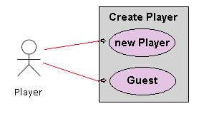

Figure 1. Use Case Diagram for Create Player.

### **General Description**

This enables for user to create a new player or sign in as a guest.

Use Case 1: Creating a player

|  |
| --- |
| **Brief Description**  Allows a new player to sign in with player name. |
| **Step-by-Step Description**   1. Player inputs name and signs in. 2. Player will be allow to see the record of wins and losses. |

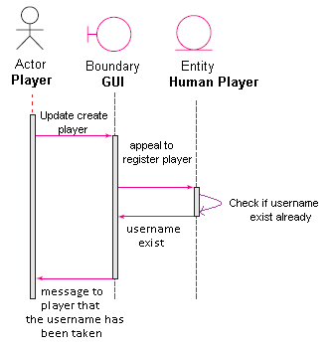

Use case 1: Player name already exist (anomaly 1)

|  |
| --- |
| **Brief Description**  Player username already exist. |
| **Step-by-Step Description**   1. Player uses name that already exist 2. Player will get a message that informs player that the username is already taken. |

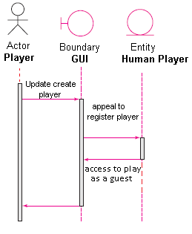

Use case1: Player plays as a guest. (Anomaly 2)

|  |
| --- |
| **Brief Description**  Player plays as a guest. |
| **Step-by-Step Description**   1. Player does not need a username and plays as a guest. 2. Guest player will not create a report of wins and losses. |

**Use Case 7**

|  |  |
| --- | --- |
| Goals of actor | Player chooses to exit game or new game |
| Tasks | Exits the game being played or starts a new game |
| Preconditions | The current game must be finished in order to quit the game or start a new game. |
| Exceptions | If there is no game, can't exit the game of start a new game. |
| Variation of action interactions | N/A |
| System change/production | N/A |

**Use Case Sequence Diagram**

***Use case 7:***

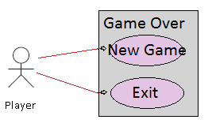

Figure 1. Use Case Diagram for Game Over

### **General Description**

This enables for user to start a new game or exit the game.

Use Case 1: Starting new game

|  |
| --- |
| **Brief Description**  Allows a player to start a new game. |
| **Step-by-Step Description**   1. Player clicks new game. 2. Player will start a new game. |

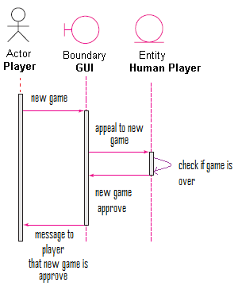

Use case 1: Player chooses new game (anomaly 1)

|  |
| --- |
| **Brief Description**  Player chooses new game. |
| **Step-by-Step Description**   1. Player chooses to start a new game. 2. Player will get a message that informs player that new game has begun. |

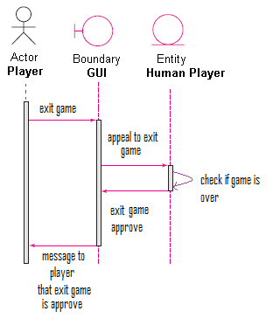

Use case1: Player chooses to exit game. (Anomaly 2)

|  |
| --- |
| **Brief Description**  Player exits game. |
| **Step-by-Step Description**   1. Player does not want to start a new game and exits game. 2. Player will not start a new game and the game will close down. |